Chapter 13

Probabilistic Reasoning
In which we explain how to build efficient network models to reason under uncertainty according to the laws of probability theory, and how to distinguish between correlation and causality.

Chapter 12 introduced the basic elements of probability theory and noted the importance of independence and conditional independence relationships in simplifying probabilistic representations of the world. This chapter introduces a systematic way to represent such relationships explicitly in the form of Bayesian networks. We define the syntax and semantics of these networks and show how they can be used to capture uncertain knowledge in a natural and efficient way. We then show how probabilistic inference, although computationally intractable in the worst case, can be done efficiently in many practical situations. We also describe a variety of approximate inference algorithms that are often applicable when exact inference is infeasible. Chapter 15 extends the basic ideas of Bayesian networks to more expressive formal languages for defining probability models.
13.1 Representing Knowledge in an Uncertain Domain
In Chapter 12, we saw that the full joint probability distribution can answer any question about the domain, but can become intractably large as the number of variables grows. Furthermore, specifying probabilities for possible worlds one by one is unnatural and tedious.
We also saw that independence and conditional independence relationships among variables can greatly reduce the number of probabilities that need to be specified in order to define the full joint distribution. This section introduces a data structure called a Bayesian network¹¹¹ to represent the dependencies among variables. Bayesian networks can represent essentially any full joint probability distribution and in many cases can do so very concisely.
A Bayesian network is a directed graph in which each node is annotated with quantitative probability information. The full specification is as follows:
- Each node corresponds to a random variable, which may be discrete or continuous.
- Directed links or arrows connect pairs of nodes. If there is an arrow from node X to node Y, X is said to be a parent of Y. The graph has no directed cycles and hence is a directed acyclic graph, or DAG.
- Each node Xi has associated probability information θ(Xi|Parents(Xi)) that quantifies the effect of the parents on the node using a finite number of parameters.
The topology of the network—the set of nodes and links—specifies the conditional independence relationships that hold in the domain, in a way that will be made precise shortly. The intuitive meaning of an arrow is typically that X has a direct influence on Y, which suggests that causes should be parents of effects. It is usually easy for a domain expert to decide what direct influences exist in the domain—much easier, in fact, than actually specifying the probabilities themselves. Once the topology of the Bayes net is laid out, we need only specify the local probability information for each variable, in the form of a conditional distribution given its parents. The full joint distribution for all the variables is defined by the topology and the local probability information.
Recall the simple world described in Chapter 12, consisting of the variables Toothache, Cavity, Catch, and Weather. We argued that Weather is independent of the other variables; furthermore, we argued that Toothache and Catch are conditionally independent, given Cavity. These relationships are represented by the Bayes net structure shown in Figure 13.1. Formally, the conditional independence of Toothache and Catch, given Cavity, is indicated by the absence of a link between Toothache and Catch. Intuitively, the network represents the fact that Cavity is a direct cause of Toothache and Catch, whereas no direct causal relationship exists between Toothache and Catch.
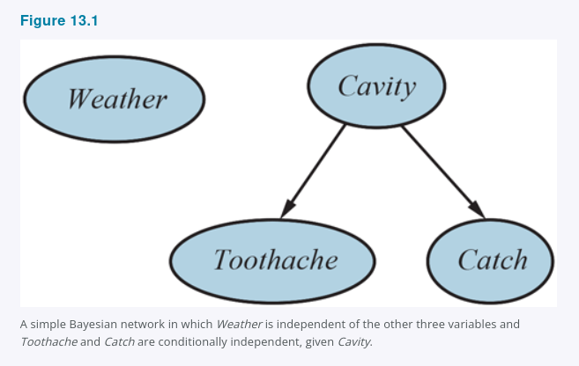
Now consider the following example, which is just a little more complex. You have a new burglar alarm installed at home. It is fairly reliable at detecting a burglary, but is occasionally set off by minor earthquakes. (This example is due to Judea Pearl, a resident of earthquake-prone Los Angeles.) You also have two neighbors, John and Mary, who have promised to call you at work when they hear the alarm. John nearly always calls when he hears the alarm, but sometimes confuses the telephone ringing with the alarm and calls then, too. Mary, on the other hand, likes rather loud music and often misses the alarm altogether. Given the evidence of who has or has not called, we would like to estimate the probability of a burglary.
A Bayes net for this domain appears in Figure 13.2. The network structure shows that burglary and earthquakes directly affect the probability of the alarm’s going off, but whether John and Mary call depends only on the alarm. The network thus represents our assumptions that they do not perceive burglaries directly, they do not notice minor earthquakes, and they do not confer before calling.
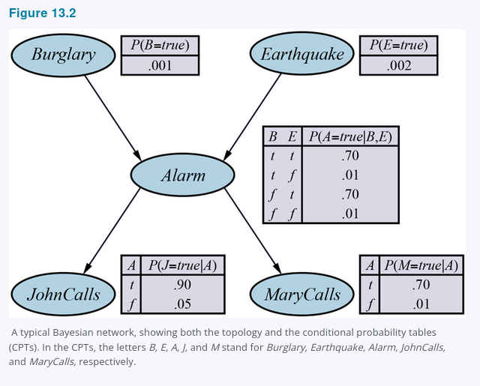
The local probability information attached to each node in Figure 13.2 takes the form of a conditional probability table (CPT). (CPTs can be used only for discrete variables; other representations, including those suitable for continuous variables, are described in Section 13.2.) Each row in a CPT contains the conditional probability of each node value for a conditioning case. A conditioning case is just a possible combination of values for the parent nodes—a miniature possible world, if you like. Each row must sum to 1, because the entries represent an exhaustive set of cases for the variable. For Boolean variables, once you know that the probability of a true value is p, the probability of false must be 1 − p, so we often omit the second number, as in Figure 13.2. In general, a table for a Boolean variable with k Boolean parents contains 2ᵏ independently specifiable probabilities. A node with no parents has only one row, representing the prior probabilities of each possible value of the variable.
Notice that the network does not have nodes corresponding to Mary’s currently listening to loud music or to the telephone ringing and confusing John. These factors are summarized in the uncertainty associated with the links from Alarm to JohnCalls and MaryCalls. This shows both laziness and ignorance in operation, as explained in Section 12.1 Acting under Uncertainty: it would be a lot of work to find out why those factors would be more or less likely in any particular case, and we have no reasonable way to obtain the relevant information anyway.
The probabilities actually summarize a potentially infinite set of circumstances in which the alarm might fail to go off (high humidity, power failure, dead battery, cut wires, a dead mouse stuck inside the bell, etc.) or John or Mary might fail to call and report it (out to lunch, on vacation, temporarily deaf, passing helicopter, etc.). In this way, a small agent can cope with a very large world, at least approximately.

13.2 The Semantics of Bayesian Networks
The syntax of a Bayes net consists of a directed acyclic graph with some local probability information attached to each node. The semantics defines how the syntax corresponds to a joint distribution over the variables of the network.
Assume that the Bayes net contains n variables, X₁, ... , Xₙ. A generic entry in the joint distribution is then
P(X₁ = x₁ ∧ ... ∧ Xₙ = xₙ), or P(x₁, ... , xₙ) for short.
The semantics of Bayes nets defines each entry in the joint distribution as follows:
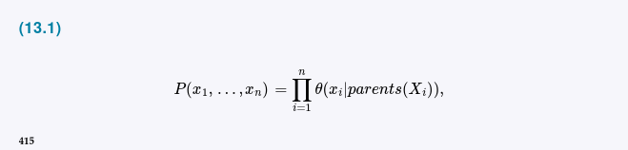
where parents(Xᵢ) denotes the values of Parents(Xᵢ) that appear in x₁, . . . , xₙ.
Thus, each entry in the joint distribution is represented by the product of the appropriate elements of the local conditional distributions in the Bayes net.
To illustrate this, we can calculate the probability that the alarm has sounded, but neither a burglary nor an earthquake has occurred, and both John and Mary call. We simply multiply the relevant entries from the local conditional distributions (abbreviating the variable names):
(The equation itself appears on the next page/image and is not visible in this screenshot.)
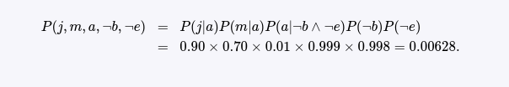

Section 12.3 explained that the full joint distribution can be used to answer any query about the domain. If a Bayes net is a representation of the joint distribution, then it too can be used to answer any query, by summing all the relevant joint probability values, each calculated by multiplying probabilities from the local conditional distributions. Section 13.3 explains this in more detail, but also describes methods that are much more efficient.
So far, we have glossed over one important point: what is the meaning of the numbers that go into the local conditional distributions θ(xᵢ|parents(Xᵢ))? It turns out that from Equation (13.1) we can prove that the parameters θ(xᵢ|parents(Xᵢ)) are exactly the conditional probabilities P(xᵢ|parents(Xᵢ)) implied by the joint distribution. Remember that the conditional probabilities can be computed from the joint distribution as follows:
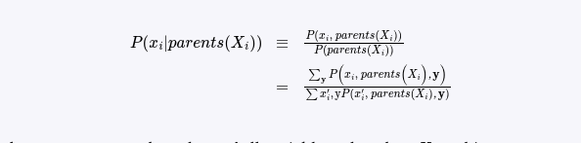

where y represents the values of all variables other than Xᵢ and its parents.
From this last line one can prove that
P(xi​∣parents(Xi​))=θ(xi​∣parents(Xi​))
(Exercise 13.CPTE).
Hence, we can rewrite Equation (13.1) as:
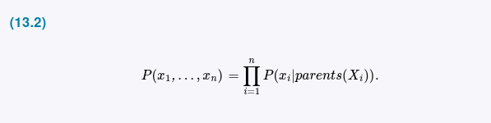
This means that when one estimates values for the local conditional distributions, they need to be the actual conditional probabilities for the variable given its parents. So, for example, when we specify θ(JohnCalls = true | Alarm = true) = 0.90, it should be the case that about 90% of the time when the alarm sounds, John calls. The fact that each parameter of the network has a precise meaning in terms of only a small set of variables is crucially important for robustness and ease of specification of the models.

A method for constructing Bayesian networks
Equation (13.2) defines what a given Bayes net means. The next step is to explain how to construct a Bayesian network in such a way that the resulting joint distribution is a good representation of a given domain. We will now show that Equation (13.2) implies certain conditional independence relationships that can be used to guide the knowledge engineer in constructing the topology of the network. First, we rewrite the entries in the joint distribution in terms of conditional probability, using the product rule (see Section 12.2 Basic Probability Notation):
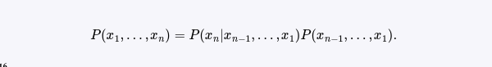
Then we repeat the process, reducing each joint probability to a conditional probability and a joint probability on a smaller set of variables. We end up with one big product:

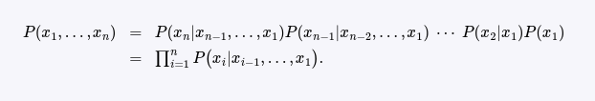

This identity is called the chain rule. It holds for any set of random variables. Comparing it with Equation (13.2), we see that the specification of the joint distribution is equivalent to the general assertion that, for every variable Xᵢ in the network,

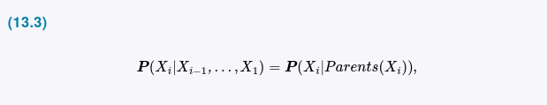

provided that Parents(Xᵢ) ⊆ {Xᵢ₋₁, . . . , X₁}. This last condition is satisfied by numbering the nodes in topological order—that is, in any order consistent with the directed graph structure. For example, the nodes in Figure 13.2 could be ordered B, E, A, J, M; E, B, A, M, J; and so on.
What Equation (13.3) says is that the Bayesian network is a correct representation of the domain only if each node is conditionally independent of its other predecessors in the node ordering, given its parents. We can satisfy this condition with this methodology:
- Nodes: First determine the set of variables that are required to model the domain. Now order them, {X₁, . . . , Xₙ}. Any order will work, but the resulting network will be more compact if the variables are ordered such that causes precede effects.
- Links: For i = 1 to n do:
  - Choose a minimal set of parents for Xᵢ from X₁, . . . , Xᵢ₋₁, such that Equation (13.3) is satisfied.
  - For each parent insert a link from the parent to Xᵢ.
  - CPTs: Write down the conditional probability table, P(Xᵢ|Parents(Xᵢ)).
Intuitively, the parents of node Xᵢ should contain all those nodes in X₁, . . . , Xᵢ₋₁ that directly influence Xᵢ. For example, suppose we have completed the network in Figure 13.2 except for the choice of parents for MaryCalls. MaryCalls is certainly influenced by whether there is a Burglary or an Earthquake, but not directly influenced. Intuitively, our knowledge of the domain tells us that these events influence Mary’s calling behavior only through their effect on the alarm. Also, given the state of the alarm, whether John calls has no influence on Mary’s calling. Formally speaking, we believe that the following conditional independence statement holds:

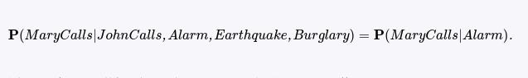
Thus, Alarm will be the only parent node for MaryCalls.
Because each node is connected only to earlier nodes, this construction method guarantees that the network is acyclic. Another important property of Bayes nets is that they contain no redundant probability values. If there is no redundancy, then there is no chance for inconsistency: it is impossible for the knowledge engineer or domain expert to create a Bayesian network that violates the axioms of probability.

Compactness and node ordering
As well as being a complete and nonredundant representation of the domain, a Bayes net can often be far more compact than the full joint distribution. This property is what makes it feasible to handle domains with many variables. The compactness of Bayesian networks is an example of a general property of locally structured (also called sparse) systems. In a locally structured system, each subcomponent interacts directly with only a bounded number of other components, regardless of the total number of components. Local structure is usually associated with linear rather than exponential growth in complexity.
In the case of Bayes nets, it is reasonable to suppose that in most domains each random variable is directly influenced by at most k others, for some constant k. If we assume n Boolean variables for simplicity, then the amount of information needed to specify each conditional probability table will be at most 2ᵏ numbers, and the complete network can be specified by 2ᵏ · n numbers. In contrast, the joint distribution contains 2ⁿ numbers. To make this concrete, suppose we have n = 30 nodes, each with five parents (k = 5). Then the Bayesian network requires 960 numbers, but the full joint distribution requires over a billion.
Specifying the conditional probability tables for a fully connected network, in which each variable has all of its predecessors as parents, requires the same amount of information as specifying the joint distribution in tabular form. For this reason, we often leave out links even though a slight dependency exists, because the slight gain in accuracy is not worth the additional complexity in the network. For example, one might object to our burglary network on the grounds that if there is a large earthquake, then John and Mary would not call even if they heard the alarm, because they assume that the earthquake is the cause. Whether to add the link from Earthquake to JohnCalls and MaryCalls (and thus enlarge the tables) depends on the importance of getting more accurate probabilities compared with the cost of specifying the extra information.
Even in a locally structured domain, we will get a compact Bayes net only if we choose the node ordering well. What happens if we happen to choose the wrong order? Consider the burglary example again. Suppose we decide to add the nodes in the order MaryCalls, JohnCalls, Alarm, Burglary, Earthquake. We then get the somewhat more complicated network shown in Figure 13.3(a). The process goes as follows:

- Adding MaryCalls: No parents.
- Adding JohnCalls: If Mary calls, that probably means the alarm has gone off, which makes it more likely that John calls. Therefore, JohnCalls needs MaryCalls as a parent.
- Adding Alarm: Clearly, if both call, it is more likely that the alarm has gone off than if just one or neither calls, so we need both MaryCalls and JohnCalls as parents.
- Adding Burglary: If we know the alarm state, then the call from John or Mary might give us information about our phone ringing or Mary’s music, but not about burglary:
Hence we need just Alarm as parent.
- Adding Earthquake: If the alarm is on, it is more likely that there has been an earthquake. (The alarm is an earthquake detector of sorts.) But if we know that there has been a burglary, then that explains the alarm, and the probability of an earthquake would be only slightly above normal. Hence, we need both Alarm and Burglary as parents.

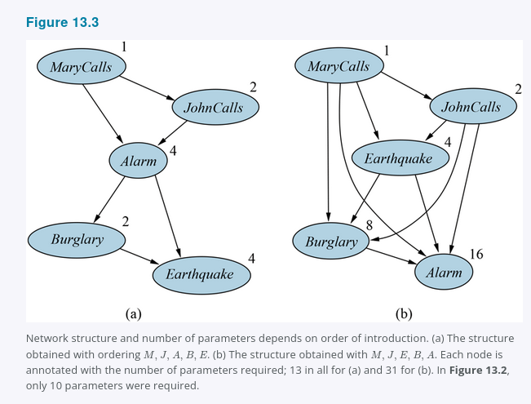

The resulting network has two more links than the original network in Figure 13.2 and requires 13 conditional probabilities rather than 10. What’s worse, some of the links represent tenuous relationships that require difficult and unnatural probability judgments, such as assessing the probability of Earthquake, given Burglary and Alarm. This phenomenon is quite general and is related to the distinction between causal and diagnostic models introduced in Section 12.5.1 (see also Exercise 13.WUMD). If we stick to a causal model, we end up having to specify fewer numbers, and the numbers will often be easier to come up with. For example, in the domain of medicine, it has been shown by Tversky and Kahneman (1982) that expert physicians prefer to give probability judgments for causal rules rather than for diagnostic ones. Section 13.5 explores the idea of causal models in more depth.
Figure 13.3(b) shows a very bad node ordering: MaryCalls, JohnCalls, Earthquake, Burglary, Alarm. This network requires 31 distinct probabilities to be specified—exactly the same number as the full joint distribution. It is important to realize, however, that any of the three networks can represent exactly the same joint distribution. The two versions in Figure 13.3 simply fail to represent all the conditional independence relationships and hence end up specifying a lot of unnecessary numbers instead.

13.2.1 Conditional independence relations in Bayesian networks
From the semantics of Bayes nets as defined in Equation (13.2), we can derive a number of conditional independence properties. We have already seen the property that a variable is conditionally independent of its other predecessors, given its parents. It is also possible to prove the more general “non-descendants” property that:
Each variable is conditionally independent of its non-descendants, given its parents.
For example, in Figure 13.2, the variable JohnCalls is independent of Burglary, Earthquake, and MaryCalls given the value of Alarm. The definition is illustrated in Figure 13.4(a).

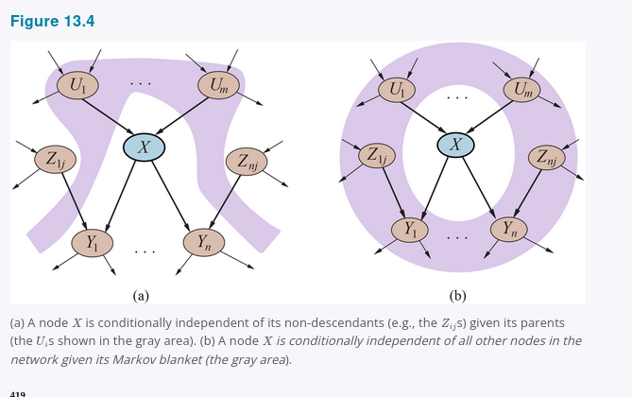

It turns out that the non-descendants property combined with interpretation of the network parameters θ(Xᵢ|Parents(Xᵢ)) as conditional probabilities P(Xᵢ|Parents(Xᵢ)) suffices to reconstruct the full joint distribution given in Equation (13.2). In other words, one can view the semantics of Bayes nets in a different way: instead of defining the full joint distribution as the product of conditional distributions, the network defines a set of conditional independence properties. The full joint distribution can be derived from those properties.
Another important independence property is implied by the non-descendants property:
a variable is conditionally independent of all other nodes in the network, given its parents, children, and children’s parents—that is, given its Markov blanket.
(Exercise 13.MARB asks you to prove this.) For example, the variable Burglary is independent of JohnCalls and MaryCalls, given Alarm and Earthquake. This property is illustrated in Figure 13.4(b). The Markov blanket property makes possible inference algorithms that use completely local and distributed stochastic sampling processes, as explained in Section 13.4.2.
The most general conditional independence question one might ask in a Bayes net is whether a set of nodes X is conditionally independent of another set Y, given a third set Z. This can be determined efficiently by examining the Bayes net to see whether Z d-separates X and Y. The process works as follows:
- Consider just the ancestral subgraph consisting of X, Y, Z, and their ancestors.
- Add links between any unlinked pair of nodes that share a common child; now we have the so-called moral graph.
- Replace all directed links by undirected links.
- If Z blocks all paths between X and Y in the resulting graph, then Z d-separates X and Y. In that case, X is conditionally independent of Y, given Z. Otherwise, the original Bayes net does not require conditional independence.
In brief, then, d-separation means separation in the undirected, moralized, ancestral subgraph. Applying the definition to the burglary network in Figure 13.2, we can deduce that Burglary and Earthquake are independent given the empty set (i.e., they are absolutely independent); that they are not necessarily conditionally independent given Alarm; and that JohnCalls and MaryCalls are conditionally independent given Alarm. Notice also that the Markov blanket property follows directly from the d-separation property, since a variable’s Markov blanket d-separates it from all other variables.

13.2.2 Efficient Representation of Conditional Distributions
Even if the maximum number of parents k is smallish, filling in the CPT for a node requires up to O(2ᵏ) numbers and perhaps a great deal of experience with all the possible conditioning cases. In fact, this is a worst-case scenario in which the relationship between the parents and the child is completely arbitrary. Usually, such relationships are describable by a canonical distribution that fits some standard pattern. In such cases, the complete table can be specified just by naming the pattern and perhaps supplying a few parameters.
The simplest example is provided by deterministic nodes. A deterministic node has its value specified exactly by the values of its parents, with no uncertainty. The relationship can be a logical one: for example, the relationship between the parent nodes Canadian, US, Mexican and the child node NorthAmerican is simply that the child is the disjunction of the parents. The relationship can also be numerical: for example, the BestPrice for a car is the minimum of the prices at each dealer in the area; and the WaterStored in a reservoir at year’s end is the sum of the original amount, plus the inflows (rivers, runoff, precipitation) and minus the outflows (releases, evaporation, seepage).
Many Bayes net systems allow the user to specify deterministic functions using a general-purpose programming language; this makes it possible to include complex elements such as global climate models or power-grid simulators within a probabilistic model.
Another important pattern that occurs often in practice is context-specific independence or CSI. A conditional distribution exhibits CSI if a variable is conditionally independent of some of its parents given certain values of others. For example, let’s suppose that the Damage to your car occurring during a given period of time depends on the Ruggedness of your car and whether or not an Accident occurred in that period. Clearly, if Accident is false, then the Damage, if any, doesn’t depend on the Ruggedness of your car. (There might be vandalism damage to the car’s paintwork or windows, but we’ll assume all cars are equally subject to such damage.) We say that Damage is context-specifically independent of Ruggedness given Accident = false. Bayes net systems often implement CSI using an if-then-else syntax for specifying conditional distributions; for example, one might write
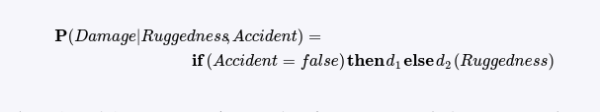
where d₁ and d₂ represent arbitrary distributions. As with determinism, the presence of CSI in a network may facilitate efficient inference. All of the exact inference algorithms mentioned in Section 13.3 can be modified to take advantage of CSI to speed up computation.
Uncertain relationships can often be characterized by so-called noisy logical relationships. The standard example is the noisy-OR relation, which is a generalization of the logical OR. In propositional logic, we might say that Fever is true if and only if Cold, Flu, or Malaria are true. The noisy-OR model allows for uncertainty about the ability of each parent to cause the child to be true—the causal relationship between parent and child may be inhibited, and so a patient could have a cold, but not exhibit a fever.
The model makes two assumptions. First, it assumes that all the possible causes are listed. (If some are missing, we can always add a so-called leak node that covers “miscellaneous causes.”) Second, it assumes that inhibition of each parent is independent of inhibition of any other parents: for example, whatever inhibits Malaria from causing a fever is independent of whatever inhibits Flu from causing a fever. Given these assumptions, Fever is false if and only if all its true parents are inhibited, and the probability of this is the product of the inhibition probabilities qᵢ for each parent. Let us suppose these individual inhibition probabilities are as follows:



Then, from this information and the noisy-OR assumptions, the entire CPT can be built. The general rule is that

where the product is taken over the parents that are set to true for that row of the CPT. Figure 13.5 illustrates this calculation.
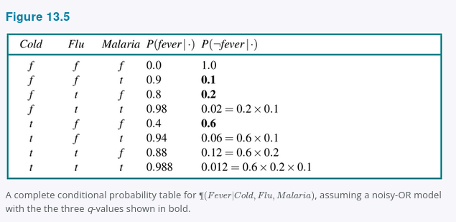
In general, noisy logical relationships in which a variable depends on k parents can be described using O(k) parameters instead of O(2ᵏ) for the full conditional probability table. This makes assessment and learning much easier. For example, the CPCS network (Pradhan et al., 1994) uses noisy-OR and noisy-MAX distributions to model relationships among diseases and symptoms in internal medicine. With 448 nodes and 906 links, it requires only 8,254 parameters instead of 133,931,430 for a network with full CPTs.

13.2.3 Bayesian nets with continuous variables
Many real-world problems involve continuous quantities, such as height, mass, temperature, and money. By definition, continuous variables have an infinite number of possible values, so it is impossible to specify conditional probabilities explicitly for each value. One way to handle continuous variables is with discretization—that is, dividing up the possible values into a fixed set of intervals. For example, temperatures could be divided into three categories: (<0°C), (0°C–100°C), and (>100°C). In choosing the number of categories, there is a tradeoff between loss of accuracy and large CPTs which can lead to slow run times.
Another approach is to define a continuous variable using one of the standard families of probability density functions (see Appendix A). For example, a Gaussian (or normal) distribution N(x; μ, σ²) is specified by just two parameters, the mean μ and the variance σ². Yet another solution—sometimes called a nonparametric representation—is to define the conditional distribution implicitly with a collection of instances, each containing specific values of the parent and child variables. We explore this approach further in Chapter 19.
A network with both discrete and continuous variables is called a hybrid Bayesian network. To specify a hybrid network, we have to specify two new kinds of distributions: the conditional distribution for a continuous variable given discrete or continuous parents; and the conditional distribution for a discrete variable given continuous parents. Consider the simple example in Figure 13.6, in which a customer buys some fruit depending on its cost, which depends in turn on the size of the harvest and whether the government’s subsidy scheme is operating. The variable Cost is continuous and has continuous and discrete parents; the variable Buys is discrete and has a continuous parent.
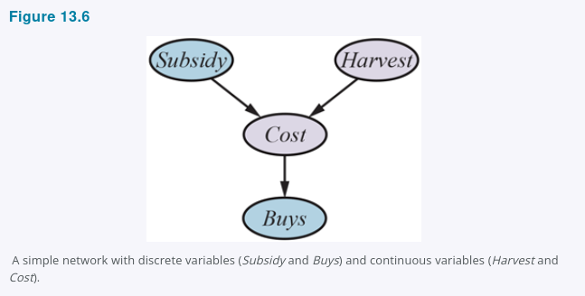

For the Cost variable, we need to specify P(Cost|Harvest, Subsidy). The discrete parent is handled by enumeration—that is, by specifying both P(Cost|Harvest, subsidy) and P(Cost|Harvest, ¬subsidy). To handle Harvest, we specify how the distribution over the cost c depends on the continuous value h of Harvest. In other words, we specify the parameters of the cost distribution as a function of h. The most common choice is the linear-Gaussian conditional distribution, in which the child has a Gaussian distribution whose mean μ varies linearly with the value of the parent and whose standard deviation σ is fixed. We need two distributions, one for subsidy and one for ¬subsidy, with different parameters:
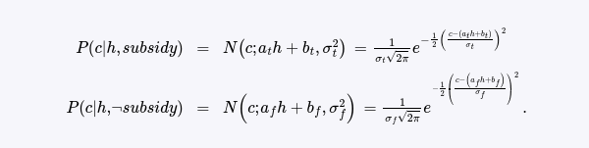
For this example, then, the conditional distribution for Cost is specified by naming the linear-Gaussian distribution and providing the parameters aₜ, bₜ, σₜ, a𝒇, b𝒇, and σ𝒇. Figures 13.7(a) and (b) show these two relationships. Notice that in each case the slope of c versus h is negative, because cost decreases as the harvest size increases. (Of course, the assumption of linearity implies that the cost becomes negative at some point; the linear model is reasonable only if the harvest size is limited to a narrow range.) Figure 13.7(c) shows the distribution P(c|h), averaging over the two possible values of Subsidy and assuming that each has prior probability 0.5. This shows that even with very simple models, quite interesting distributions can be represented.
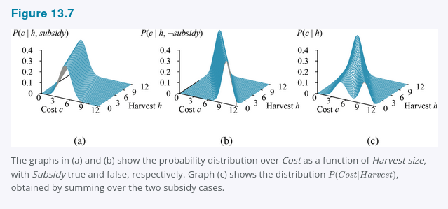
The linear-Gaussian conditional distribution has some special properties. A network containing only continuous variables with linear-Gaussian distributions has a joint distribution that is a multivariate Gaussian distribution (see Appendix A) over all the variables (Exercise 13.LGEX). Furthermore, the posterior distribution given any evidence also has this property.¹¹² When discrete variables are added as parents (not as children) of continuous variables, the network defines a conditional Gaussian, or CG, distribution: given any assignment to the discrete variables, the distribution over the continuous variables is a multivariate Gaussian.
Now we turn to the distributions for discrete variables with continuous parents. Consider, for example, the Buys node in Figure 13.6. It seems reasonable to assume that the customer will buy if the cost is low and will not buy if it is high and that the probability of buying varies smoothly in some intermediate region. In other words, the conditional distribution is like a “soft” threshold function. One way to make soft thresholds is to use the integral of the standard normal distribution:
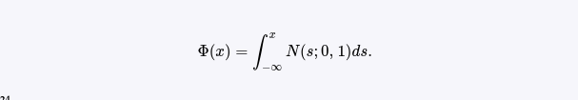
Φ(x) is an increasing function of x, whereas the probability of buying decreases with cost, so here we flip the function around:


which means that the cost threshold occurs around μ, the width of the threshold region is proportional to σ, and the probability of buying decreases as cost increases. This probit model (pronounced “pro-bit” and short for “probability unit”) is illustrated in Figure 13.8(a). The form can be justified by proposing that the underlying decision process has a hard threshold, but that the precise location of the threshold is subject to random Gaussian noise.
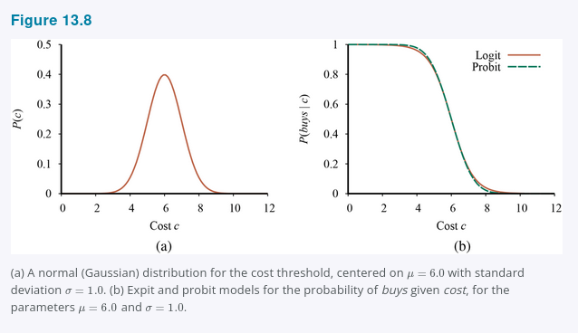

An alternative to the probit model is the expit or inverse logit model. It uses the logistic function (1/(1 + e^{-x})) to produce a soft threshold—it maps any (x) to a value between 0 and 1. Again, for our example, we flip it around to make a decreasing function; we also scale the exponent by (4/\sqrt{2\pi}) to match the probit’s slope at the mean:
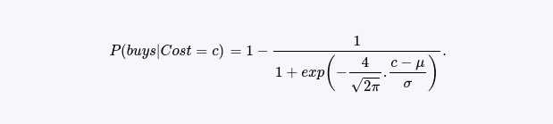
This is illustrated in Figure 13.8(b). The two distributions look similar, but the logit actually has much longer “tails.” The probit is often a better fit to real situations, but the logistic function is sometimes easier to deal with mathematically. It is used widely in machine learning. Both models can be generalized to handle multiple continuous parents by taking a linear combination of the parent values. This also works for discrete parents if their values are integers; for example, with k Boolean parents, each viewed as having values 0 or 1, the input to the expit or probit distribution would be a weighted linear combination with k parameters, yielding a model quite similar to the noisy-OR model discussed earlier.

13.2.4 Case study: Car insurance
A car insurance company receives an application from an individual to insure a specific vehicle and must decide on the appropriate annual premium to charge, based on the anticipated claims it will pay out for this applicant. The task is to build a Bayes net that captures the causal structure of the domain and gives an accurate, well-calibrated distribution over the output variables given the evidence available from the application form.¹¹³ The Bayes net will include hidden variables that are neither input nor output variables, but are essential for structuring the network so that it is reasonably sparse with a manageable number of parameters. The hidden variables are shaded brown in Figure 13.9.

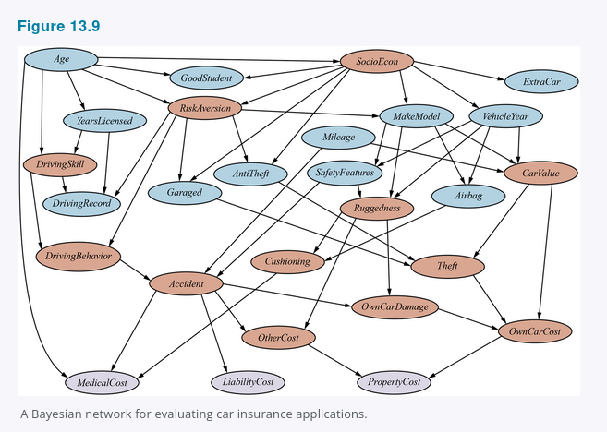

The claims to be paid out—shaded lavender in Figure 13.9—are of three kinds: the MedicalCost for any injuries sustained by the applicant; the LiabilityCost for lawsuits filed by other parties against the applicant and the company; and the PropertyCost for vehicle damage to either party and vehicle loss by theft. The application form asks for the following input information (the light blue nodes in Figure 13.9):
- About the applicant: Age; YearsLicensed—how long since a driving license was first obtained; DrivingRecord—some summary, perhaps based on “points,” of recent accidents and traffic violations; and (for students) a GoodStudent indicator for a grade-point average of 3.0 (B) on a 4-point scale.
- About the vehicle: the MakeModel and VehicleYear; whether it has an Airbag; and some summary of SafetyFeatures such as anti-lock braking and collision warning.
- About the driving situation: the annual Mileage driven and how securely the vehicle is Garaged, if at all.
Now we need to think about how to arrange these into a causal structure. The key hidden variables are whether or not a Theft or Accident will occur in the next time period. Obviously, one cannot ask the applicant to predict these; they have to inferred from the available information and the insurer’s previous experience.
What are the causal factors leading to Theft? The MakeModel is certainly important—some models are stolen much more often than others because there is an efficient resale market for vehicles and parts; the CarValue also matters, because an old, beat-up, or high-mileage vehicle has lower resale value. Moreover, a vehicle that is Garaged and has an AntiTheft device is harder to steal. The hidden variable CarValue depends in turn on the MakeModel, VehicleYear, and Mileage. CarValue also dictates the loss amount when a Theft occurs, so that is one of the contributors to OwnCarCost (the other being accidents, which we will get to shortly).
It is common in models of this type to introduce another hidden variable, SocioEcon, the socioeconomic category of the applicant. This is thought to influence a wide range of behaviors and characteristics. In our model, there is no direct evidence in the form of observed income and occupation variables,¹¹⁴ but SocioEcon influences MakeModel and VehicleYear; it also affects ExtraCar and GoodStudent, and depends somewhat on Age.
For any insurance company, perhaps the most important hidden variable is RiskAversion: people who are risk-averse are good insurance risks! Age and SocioEcon affect RiskAversion, and its “symptoms” include the applicant’s choice of whether the vehicle is Garaged and has AntiTheft devices and SafetyFeatures.
In predicting future accidents, the key is the applicant’s future DrivingBehavior, which is influenced by both RiskAversion and DrivingSkill; the latter in turn depends on Age and YearsLicensed. The applicant’s past driving behavior is reflected in the DrivingRecord, which also depends on RiskAversion and DrivingSkill as well as on YearsLicensed (because someone who started driving only recently may not have had time to accumulate a litany of accidents and violations). In this way, DrivingRecord provides evidence about RiskAversion and DrivingSkill, which in turn help to predict future DrivingBehavior.
We can think of DrivingBehavior as a per-mile tendency to drive in an accident-prone way; whether an Accident actually occurs in a fixed time period depends also on the annual Mileage and on the SafetyFeatures of the vehicle. If an Accident occurs, there are three kinds of costs: the MedicalCost for the applicant depends on Age and Cushioning, which also depends in turn on the Ruggedness of the car and whether it has an Airbag; the LiabilityCost (medical, pain and suffering, loss of income, etc.) for the other driver; and the PropertyCost for the applicant and the other driver, both of which depend (in different ways) on the car’s Ruggedness and on the applicant’s CarValue.

We have illustrated the kind of reasoning that goes into developing the topology and hidden variables in a Bayes net. We also need to specify the ranges and the conditional distributions for each variable. For the ranges, the primary decision is often whether to make the variable discrete or continuous. For example, the Ruggedness of the vehicle could be a continuous variable between 0 and 1, or a discrete variable with range {TinCan, Normal, Tank}.
Continuous variables provide more precision, but they make exact inference impossible except in a few special cases. A discrete variable with many possible values can make it tedious to fill in the correspondingly large conditional probability tables and makes exact inference more expensive unless the variable’s value is always observed. For example, MakeModel in a real system would have thousands of possible values, and this causes its child CarValue to have an enormous CPT that would have to be filled in from industry databases; but, because the MakeModel is always observed, this does not contribute to inference complexity: in fact, the observed values for the three parents pick out exactly one relevant row of the CPT for CarValue.
The conditional distributions in the model are given in the code repository for the book; we provide a version with only discrete variables, for which exact inference can be performed. In practice, many of the variables would be continuous and the conditional distributions would be learned from historical data on applicants and their insurance claims. We will see how to learn Bayes net models from data in Chapter 20.
The final question is, of course, how to do inference in the network to make predictions. We turn now to this question. For each inference method that we describe, we will evaluate the method on the insurance net to measure the time and space requirements of the method.

13.3 Exact Inference in Bayesian Networks
The basic task for any probabilistic inference system is to compute the posterior probability distribution for a set of query variables, given some observed event—usually, some assignment of values to a set of evidence variables.¹¹⁵ To simplify the presentation, we will consider only one query variable at a time; the algorithms can easily be extended to queries with multiple variables. (For example, we can solve the query P(U, V|e) by multiplying P(V|e) and P(U|V, e).) We will use the notation from Chapter 12: X denotes the query variable; E denotes the set of evidence variables E₁, . . . , Eₘ, and e is a particular observed event; Y denotes the hidden (nonevidence, nonquery) variables Y₁, . . . , Yℓ. Thus, the complete set of variables is {X} ∪ E ∪ Y. A typical query asks for the posterior probability distribution P(X|e).
In the burglary network, we might observe the event in which JohnCalls = true and MaryCalls = true. We could then ask for, say, the probability that a burglary has occurred:
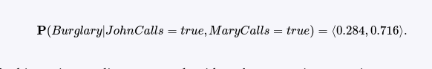
In this section we discuss exact algorithms for computing posterior probabilities as well as the complexity of this task. It turns out that the general case is intractable, so Section 13.4 covers methods for approximate inference.

13.3.1 Inference by enumeration
Chapter 12 explained that any conditional probability can be computed by summing terms from the full joint distribution. More specifically, a query P(X|e) can be answered using Equation (12.9), which we repeat here for convenience:
(The equation itself is not visible in the provided image and appears on the next page.)

Now, a Bayes net gives a complete representation of the full joint distribution. More specifically, Equation (13.2) in Section 13.2 on The Semantics of Bayesian Networks shows that the terms P(x, e, y) in the joint distribution can be written as products of conditional probabilities from the network. Therefore,
a query can be answered using a Bayes net by computing sums of products of conditional probabilities from the network.
Consider the query
The hidden variables for this query are Earthquake and Alarm. From Equation (12.9), using initial letters for the variables to shorten the expressions, we have

The semantics of Bayes nets (Equation (13.2)) then gives us an expression in terms of CPT entries. For simplicity, we do this just for Burglary = true:
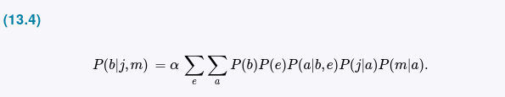
This expression can be evaluated by looping through the variables in order, multiplying CPT entries as we go. For each summation, we also need to loop over the variable’s possible values. The structure of this computation is shown as a tree in Figure 13.10. Using the numbers from Figure 13.2, we obtain
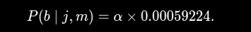
The corresponding computation for (\neg b) yields
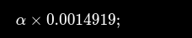
hence,

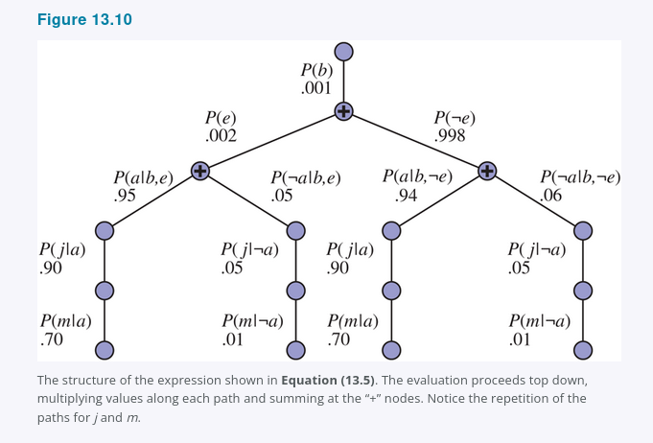

That is, the chance of a burglary, given calls from both neighbors, is about 28%.
The ENUMERATION-ASK algorithm in Figure 13.11 evaluates these expression trees using depth-first, left-to-right recursion. The algorithm is very similar in structure to the backtracking algorithm for solving CSPs (Figure 6.5) and the DPLL algorithm for satisfiability (Figure 7.17). Its space complexity is only linear in the number of variables: the algorithm sums over the full joint distribution without ever constructing it explicitly. Unfortunately, its time complexity for a network with (n) Boolean variables (not counting the evidence variables) is always (O(2^n))—better than the (O(n2^n)) for the simple approach described earlier, but still rather grim. For the insurance network in Figure 13.9, which is relatively small, exact inference using enumeration requires around 227 million arithmetic operations for a typical query on the cost variables.

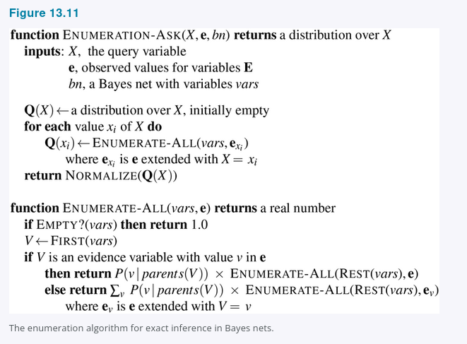
If you look carefully at the tree in Figure 13.10, however, you will see that it contains repeated subexpressions. The products (P(j \mid a)P(m \mid a)) and (P(j \mid \neg a)P(m \mid \neg a)) are computed twice, once for each value of (E). The key to efficient inference in Bayes nets is avoiding such wasted computations. The next section describes a general method for doing this.
13.3.2 The variable elimination algorithm
The enumeration algorithm can be improved substantially by eliminating repeated calculations of the kind illustrated in Figure 13.10. The idea is simple: do the calculation once and save the results for later use. This is a form of dynamic programming. There are several versions of this approach; we present the variable elimination algorithm, which is the simplest. Variable elimination works by evaluating expressions such as Equation (13.5) in right-to-left order—that is, bottom up in Figure 13.10. Intermediate results are stored, and summations over each variable are done only for those portions of the expression that depend on the variable.
Let us illustrate this process for the burglary network. We evaluate the expression
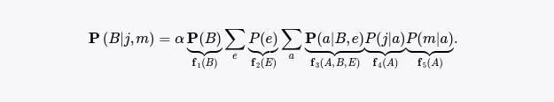
Notice that we have annotated each part of the expression with the name of the corresponding factor; each factor is a matrix indexed by the values of its argument variables. For example, the factors (f_4(A)) and (f_5(A)) corresponding to (P(j \mid a)) and (P(m \mid a)) depend just on (A) because (J) and (M) are fixed by the query. They are therefore two-element vectors:
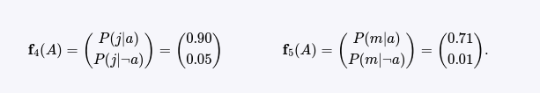
(f_3(A, B, E)) will be a (2 \times 2 \times 2) matrix, which is hard to show on the printed page. (The “first” element is given by (P(a \mid b, e) = 0.95) and the “last” by (P(\neg a \mid \neg b, \neg e) = 0.999).) In terms of factors, the query expression is written as
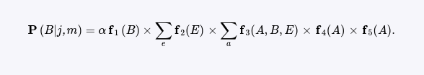

Here the “(\times)” operator is not ordinary matrix multiplication but instead the pointwise product operation, to be described shortly.
The evaluation process sums out variables (right to left) from pointwise products of factors to produce new factors, eventually yielding a factor that constitutes the solution—that is, the posterior distribution over the query variable. The steps are as follows:
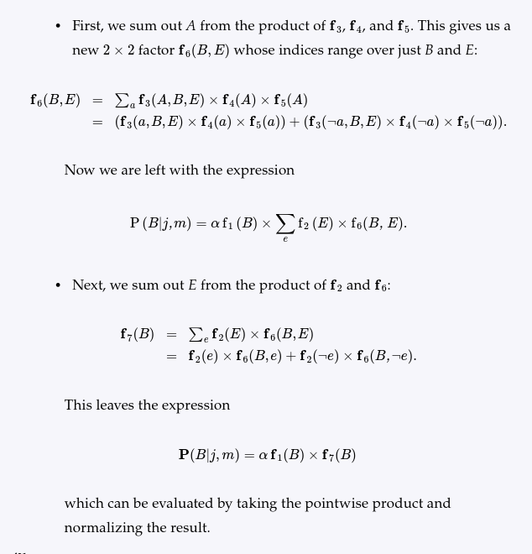

Examining this sequence, we see that two basic computational operations are required: pointwise product of a pair of factors, and summing out a variable from a product of factors. The next section describes each of these operations.

Operations on factors
The pointwise product of two factors f and g yields a new factor h whose variables are the union of the variables in f and g and whose elements are given by the product of the corresponding elements in the two factors. Suppose the two factors have variables (Y_1, \ldots, Y_k) in common. Then we have
